How does the Internet Work?
The Internet is the backbone of the Web, the technical infrastructure that makes the Web possible. At its most basic, the Internet is a large network of computers which communicate all together. The history of the Internet is somewhat obscure. It began in the 1960s as a US-army-funded research project, then evolved into a public infrastructure in the 1980s with the support of many public universities and private companies. The various technologies that support the Internet have evolved over time, but the way it works hasn't changed that much: Internet is a way to connect computers all together and ensure that, whatever happens, they find a way to stay connected.

A simple network
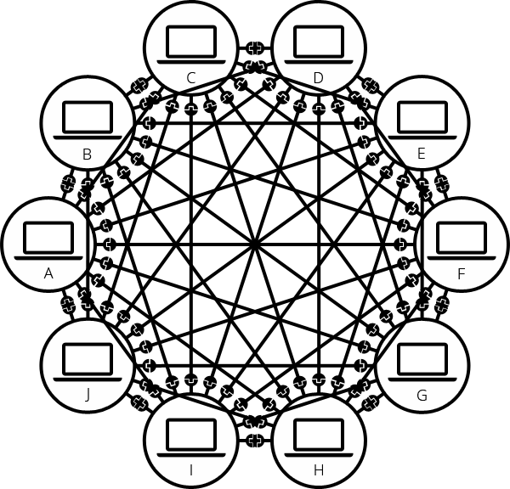
When two computers need to communicate, you have to link them, either physically (usually with an Ethernet cable) or wirelessly (for example with WiFi or Bluetooth systems). All modern computers can sustain any of those connections.
Such a network is not limited to two computers. You can connect as many computers as you wish. But it gets complicated quickly. If you're trying to connect, say, ten computers, you need 45 cables, with nine plugs per computer!
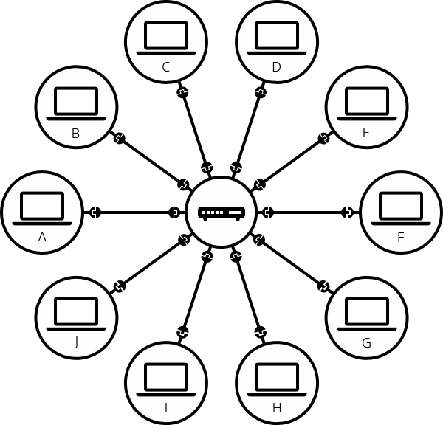
To solve this problem, each computer on a network is connected to a special tiny computer called a router. This router has only one job: like a signaler at a railway station, it makes sure that a message sent from a given computer arrives at the right destination computer. To send a message to computer B, computer A must send the message to the router, which in turn forwards the message to computer B and makes sure the message is not delivered to computer C.
Once we add a router to the system, our network of 10 computers only requires 10 cables: a single plug for each computer and a router with 10 plugs.

A network of networks
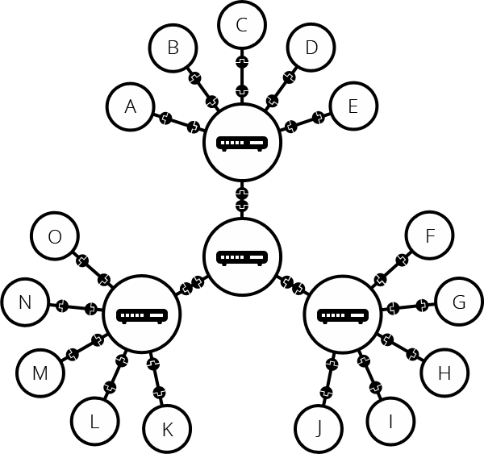
So far so good. But what about connecting hundreds, thousands, billions of computers? Of course a single router can't scale that far, but, if you read carefully, we said that a router is a computer like any other, so what keeps us from connecting two routers together? Nothing, so let's do that.
By connecting computers to routers, then routers to routers, we are able to scale infinitely.
Such a network comes very close to what we call the Internet, but we're missing something. We built that network for our own purposes. There are other networks out there: your friends, your neighbors, anyone can have their own network of computers. But it's not really possible to set cables up between your house and the rest of the world, so how can you handle this? Well, there are already cables linked to your house, for example, electric power and telephone. The telephone infrastructure already connects your house with anyone in the world so it is the perfect wire we need. To connect our network to the telephone infrastructure, we need a special piece of equipment called a modem. This modem turns the information from our network into information manageable by the telephone infrastructure and vice versa.
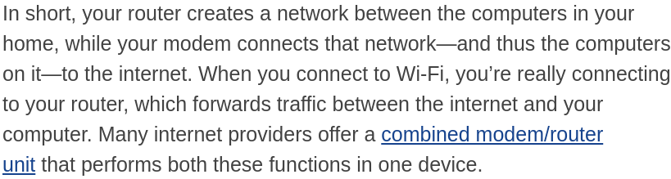
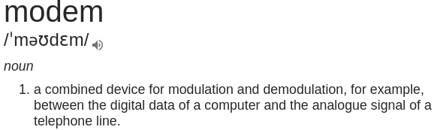

What a Router Does
A router connects multiple networks and routes network traffic between them. It’s really that simple. In the case of your home network, your router has one connection to the Internet and one connection to your private local network. In addition, most routers also contain built-in switches that let you connect multiple wired devices. Many also contain wireless radios that let you connect Wi-Fi devices.
The simple way to think about routers—especially on your home network—is like this. The router sits in between your Internet connection and your local network. It lets you connect multiple devices to the Internet through one physical Internet connection and also lets those devices communicate with one another over the local network. In addition, the router offers some protection to your devices over being exposed directly to the Internet. To the Internet, all the traffic coming from your house looks like it’s coming from a single device. The router keeps track of what traffic goes to which actual device on your network.
But you can’t connect directly to the Internet with just a router. Instead, your router must be plugged into a device that can transmit your digital traffic over whatever type of Internet connection you have. And that device is a modem.

What a Modem Does
Your modem serves as a bridge between your local network and the Internet. Historically, the term “modem” is shorthand for modulator-demodulator. Modems were used to modulate the signals on telephone lines so that digital information could be encoded and transmitted over them and then demodulated—and decoded—on the other end. Though more modern broadband connections—like cable and satellite—don’t really work the same way, we kept using the term “modem” because it’s a device people were already familiar with and associated with connecting to the Internet.
How a modem attaches to your network depends on the type of connection you have. The modem plugs into whatever type of infrastructure you have—cable, telephone, satellite, or fiber—and gives you a standard Ethernet cable output that you can plug into any router (or a single computer) and get an Internet connection.
Since the modem communicates with your Internet service provider, you’ll need the correct type of modem that will work with your ISP’s infrastructure.

Combined Routers and Modems
Some ISPs offer a modem and router in a single device. That device has the electronics and software in it to provide both functions, acting as a modem that communicates with your ISP and functioning as a router to create a home network. Some ISPs also bundle a phone interface into the same box so you can use their VOIP offerings.
While a combined unit has its attractions—just having one device cluttering up your office being one—there are also disadvantages. Using separate devices offers more flexibility in what you can do with your network and lets you make sure you’re using the best quality devices you can. And using your own devices instead of the ones your ISP provides can save you some money.
Dial-up Modems
The very first modems (created in the 1950s and 1960s) were used by the U.S. Department of Defense, news services, and some large businesses. They operated at speeds measured as 110 and 300 baud (a unit of analog signal measurement named after Emile Baudot), equivalent to 110-300 bits per second (bps). Modern dial-up modems can only reach a maximum of 56 Kbps (0.056 Mbps) due to technical limitations. However, inherent limitations of public telephone networks often limit modem data rates to 33.6 Kbps or lower in practice
Modems gradually became familiar to consumers in the late '70s through the '80s as public message boards and news services like CompuServe were built on early internet infrastructure. Then, with the explosion of the World Wide Web in the mid and late 1990s, dial-up modems emerged as the primary form of internet access in many households around the world.
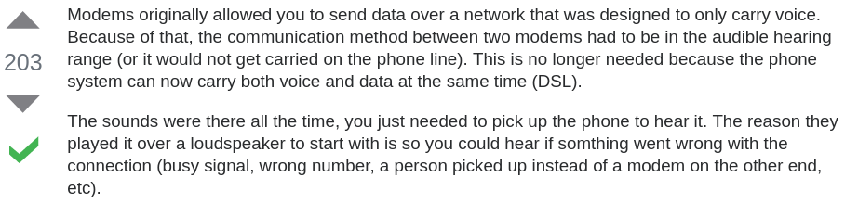

Dial-up Network vs DSL vs Cable
Dial-up and Digital Subscriber Line (DSL) technologies both enable Internet access over telephone lines. DSL achieves speeds more than 100 times that of dial-up through its advanced digital signaling technology. DSL also functions at very high signal frequencies that allows a household to use the same phone line for both voice calls and Internet service. In contrast, dial-up requires exclusive access to the phone line; when connected to dial-up Internet, the household cannot use it to make voice calls.
Dial-up systems utilize special-purpose network protocols like Point-to-Point Protocol (PPP), that later became the basis for the PPP over Ethernet (PPPoE) technology used with DSL.
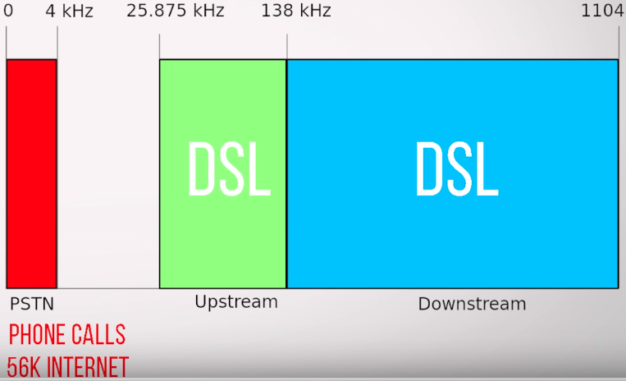
The phone conversations take up only a small amount of space in our telephone line “tube”. The rest of the tube can be used for the internet data packets. Which are kept seperate by simply using a different frequency band.
Dial-up connections could only use frequencies that were dedicated to phone traffic. That is why they are technically limited to 56kb.
ISP’s generally assign much more of the available bandwidth to downstream traffic rather than upstream (ADSL, Asymmetric)
DSL vs Cable
- With DSL your connection to the ISP is your own. But the bandwidth on an incoming cable connection is often shared by many other people in your neighbourhood.
- But the farther you are physically located to your ISP (or to one of their stations) the slower your dsl connection will be.
- The coaxial cable uses TV channel space (cable TV lines) for data transmission and provides much greater bandwidth than telephone lines
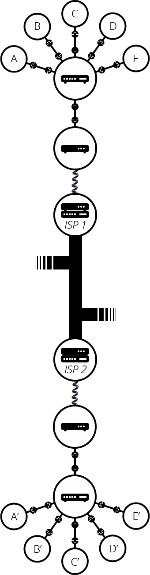
So we are connected to the telephone infrastructure. The next step is to send the messages from our network to the network we want to reach. To do that, we will connect our network to an Internet Service Provider (ISP). An ISP is a company that manages some special routers that link all together and can also access other ISPs' routers. So the message from our network is carried through the network of ISP networks to the destination network. The Internet consists of this whole infrastructure of networks.
Finding computers
If you want to send a message to a computer, you have to specify which one. Thus any computer linked to a network has a unique address to identify it, called an "IP address" (where IP stands for Internet Protocol). It's an address made of a series of four numbers separated by dots, for example: 192.168.2.10. That's perfectly fine for computers, but we human beings have a hard time remembering that sort of address. To make things easier, we can alias an IP address with a human readable name called a domain name. For example, google.com is the domain name used on top of the IP address 173.194.121.32. So using the domain name is the easiest way for us to reach a computer over the Internet.

Internet vs World Wide Web (web)
As you might notice, when we browse the Web with a Web browser, we usually use the domain name to reach a website. Does that mean the Internet and the Web are the same thing? It's not that simple. As we saw, the Internet is a technical infrastructure which allows billions of computers to be connected all together. Among those computers, some computers (called Web servers) can send messages intelligible to web browsers. The Internet is an infrastructure, whereas the Web is a service built on top of the infrastructure. It is worth noting there are several other services built on top of the Internet, such as email and IRC.
What is The Internet?
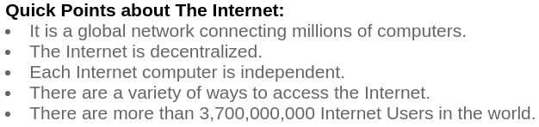
Internet is a massive network of networks, a networking infrastructure. It connects millions of computers together globally, forming a network in which any computer can communicate with any other computer as long as they are both connected to the Internet. Information that travels over the Internet does so via a variety of languages known as protocols.

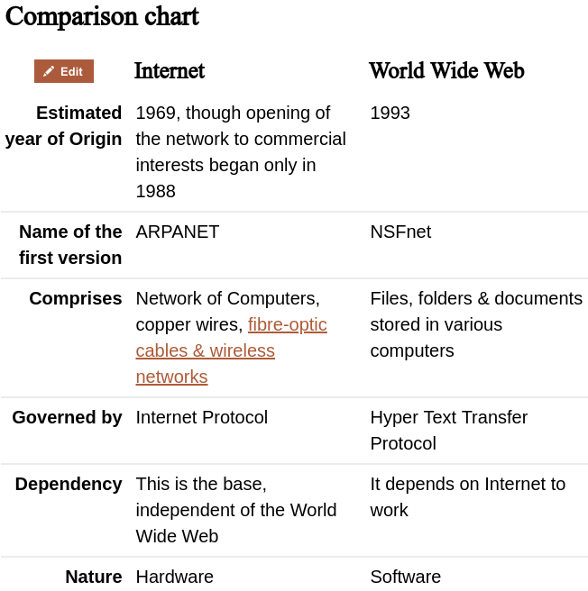
What is The Web (World Wide Web)?
World Wide Web, or simply Web, is a way of accessing information over the medium of the Internet. It is an information-sharing model that is built on top of the Internet. The Web uses the HTTP protocol, only one of the languages spoken over the Internet, to transmit data. Web services, which use HTTP to allow applications to communicate in order to exchange business logic, use the the Web to share information. The Web also utilizes browsers, such as Internet Explorer or Firefox, to access Web documents called Web pages that are linked to each other via hyperlinks. Web documents also contain graphics, sounds, text and video.
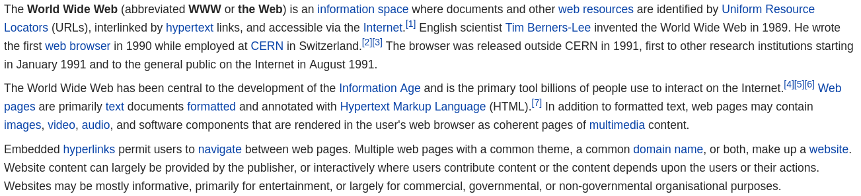
Summary
The Internet is actually a huge network that is accessible to everyone & everywhere across the world. The network is composed of sub-networks comprising of a number of computers that are enabled to transmit data in packets. The internet is governed by a set of rules, laws & regulations, collectively known as the Internet Protocol (IP). The sub-networks may range from defense networks to academic networks to commercial networks to individual PCs. Internet, essentially provides information & services in the form of E-Mail, chat & file transfers. It also provides access to the World Wide Web & other interlinked web pages.
The Internet & the World Wide Web (the Web), though used interchangeably, are not synonymous. Internet is the hardware part - it is a collection of computer networks connected through either copper wires, fiber-optic cables or wireless connections whereas, the World Wide Web can be termed as the software part – it is a collection of web pages connected through hyperlinks and URLs. In short, the World Wide Web is one of the services provided by the Internet. Other services over the Internet include e-mail, chat and file transfer services. All of these services can be provided to consumers for use by businesses or government or by individuals creating their own networks or platforms.
Another method to differentiate between both is using the Protocol Suite – a collection of laws & regulations that govern the Internet. While internet is governed by the Internet Protocol – specifically dealing with data as whole and their transmission in packets, the World Wide Web is governed by the Hyper Text Transfer Protocol (HTTP) that deals with the linking of files, documents and other resources of the World Wide Web.

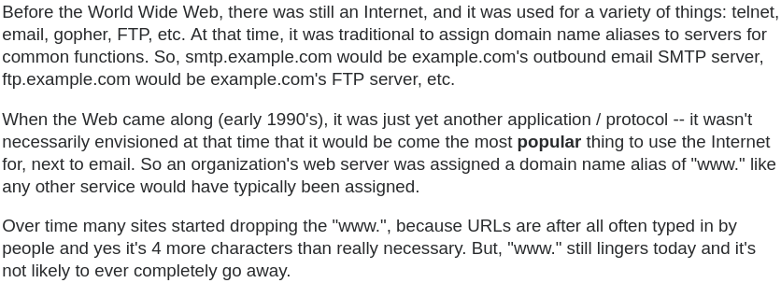
- Apart from the World Wide Web, the Internet also carries traffic for email, peer-to-peer file sharing, virtual private networks, encrypted financial transactions, online games, Internet telephony (net phones, such as the Vonage service), instant messaging (like AIM), and lots and lots of other things, some of which integrate with the web to a greater or lesser degree.
the World Wide Web makes use of hypertext to access the various forms of information available on the world's different networks. HTTP’de gönderilen hypertext. GET / POST vs. farklı resourcelara GET diyorsun, server bunu okuyup sana yine hypertext gönderiyor 200 OK, Headerlar body vs…
Daha teknik olaya girmek lazım
TCP IP ve alt bütün protokoller nedir nasıl çalışır
Paketlere nasıl bölünür. Kendimiz yazabilir miyiz?
Paket içeriği nasıl görünür vs vs...

